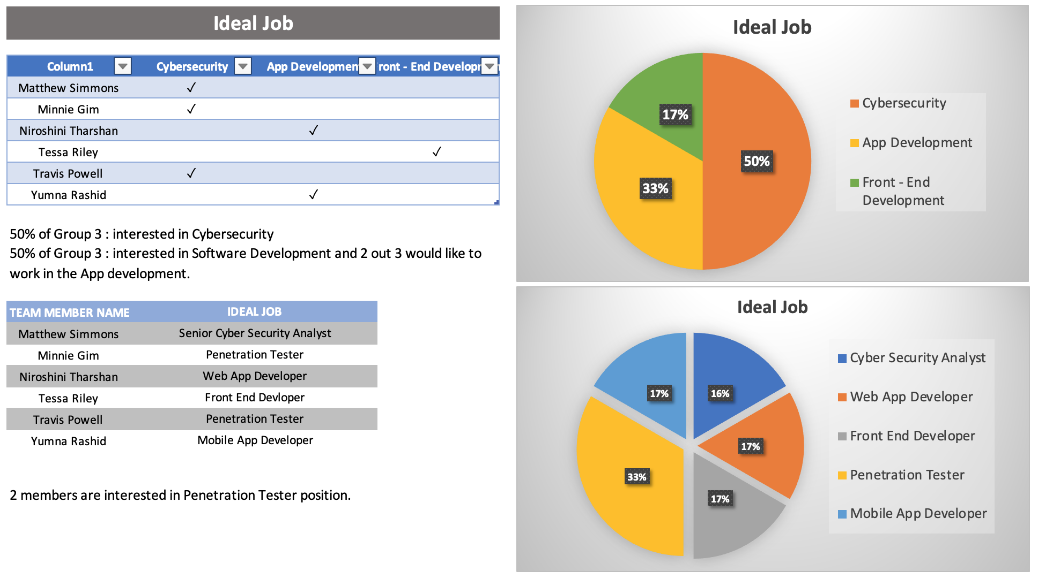



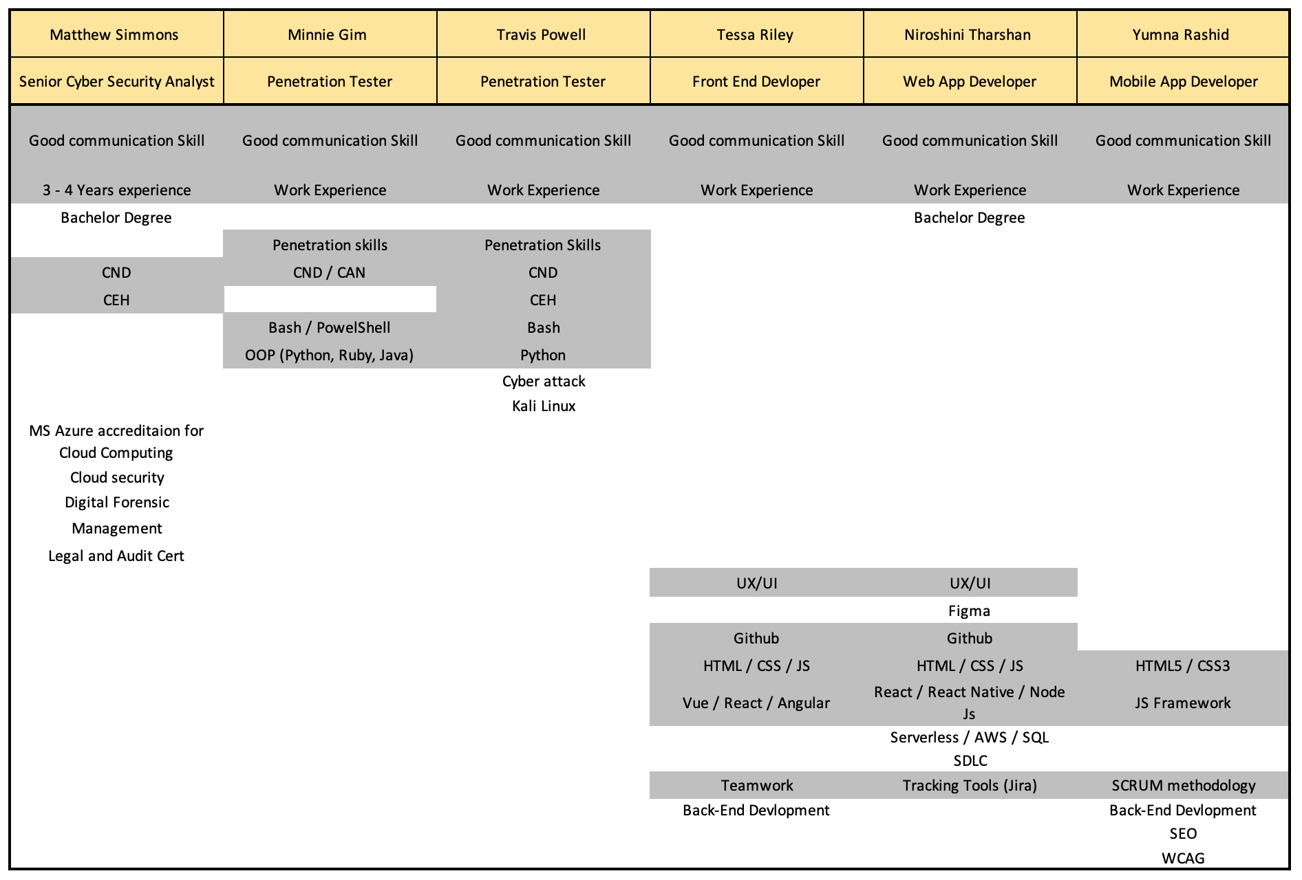



**> SIMILARITY**

The positions in Cybersecurity are expected to employees having CND (Certified Network Defence).

The most popular cybersecurity position is a penetration tester in Group 3. It is required to have knowledge of OOP such as python and Command language Bash.

**> DIFFERENCES**

Cyber Security Analyst is a senior role, so it is required more skills and knowledge in management.

On these positions, penetration tester is not searching for bachelor’s degree holder, while senior cyber security analyst is.

**> CONCLUSION**

Therefore, for the future senior role, it is important to have bachelor’s degree, management knowledge and extended knowledge in cloud computing.

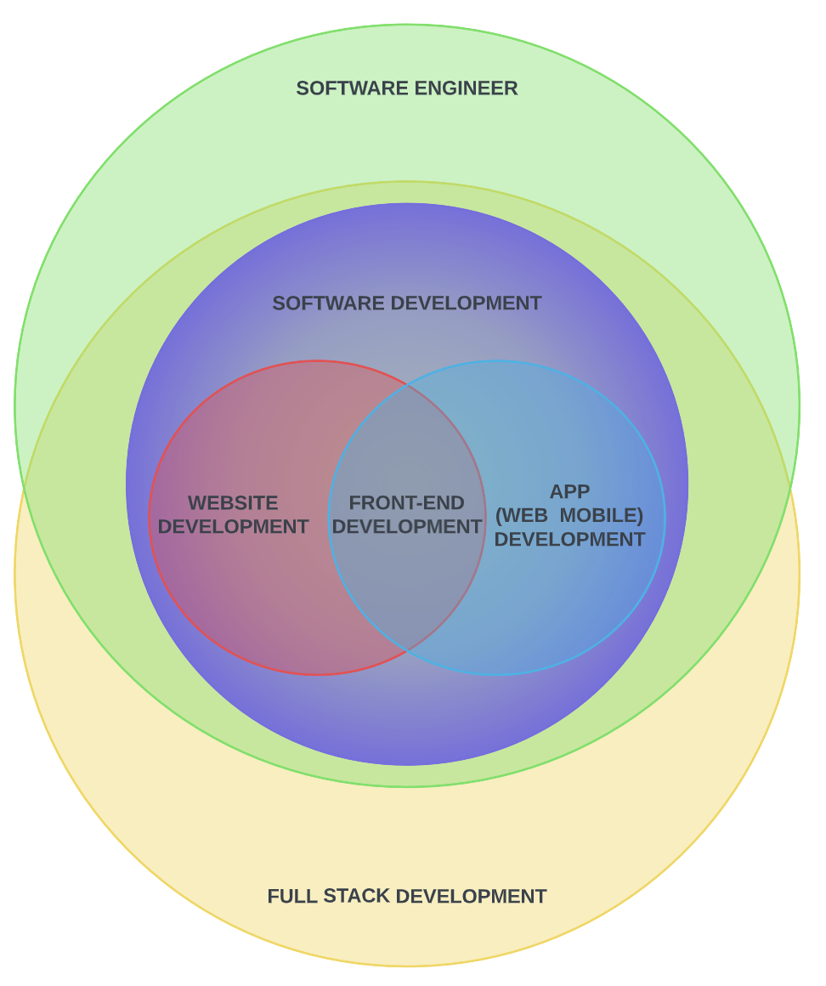

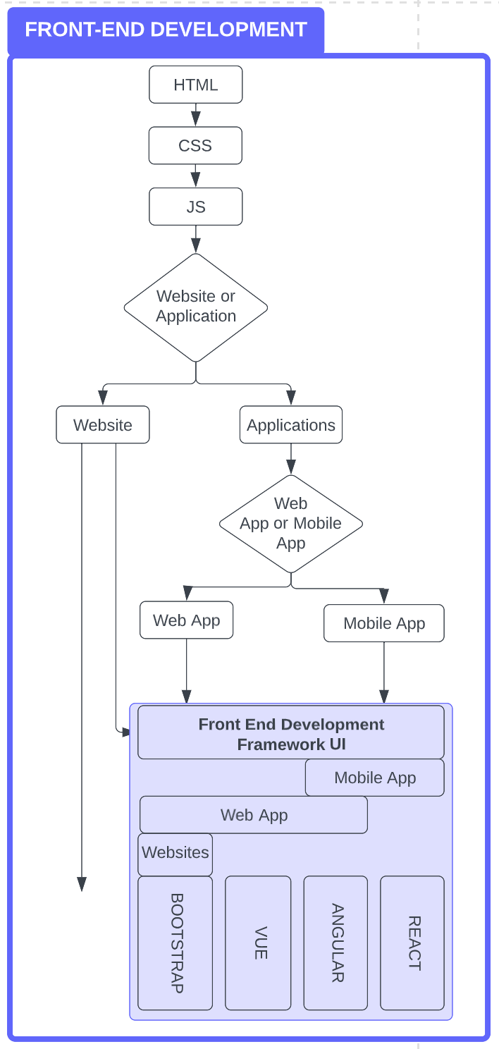

Front-End Development is a part of App Development. (Please see the attached Venn Diagram)

**> SIMILARITY**

All app development positions are required Front End Development Framework UI knowledge such as React and JS Framework.

Teamwork is important in Software Development and collaborate via using GitHub and SCRUM.

Software Development positions are expecting knowledge of Back-End Development as well as Front-End.

**> DIFFERENCES**

Web App Developer position is seeking an employee who has SDLC knowledge.

**> CONCLUSION**

Similar skills and knowledge are required in software development.

Front End Developer can apply App Development with additional knowledge in Back-End Development.